Task

Calculation of survey scores

# Input:

set of files

**Games.xlsx  
Macro.xlsx  
Rummy.xlsx**

* Each file is type of audience
* Each row is a separate response of different customer

# Output:

Brand_scores.csv

Keyword_scores.csv

# For Brand_scores.csv

1.Brand scores  
These are the four scores need to be calculated

1. unaided_brand_awareness_score
2. aided_brand_awareness_score
3. brand_consideration
4. overall_brand_consideration

## Step -1

Calculate count of responses received for each brand according to date  
First take a combination of date (available in **input file**-column name- “**Started Time”)** and available brands.  
Take start_date and end_date same  
  
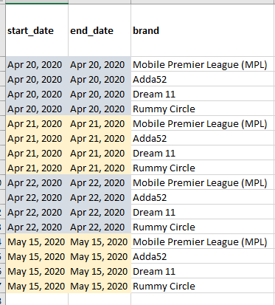

**This table has specification to use the question responses to calculate that respective score**

|  |  |  |
| --- | --- | --- |
| **Score** | **Brand** | **Questions-(columns of Input files)** |
| **unaided_brand_awareness_score** | ALL brands | Which is the first brand that comes to your mind for online ​mobile gaming? |
| **aided_brand_awareness_score** | Mobile Premier League (MPL) | Which of the following brands have you heard of?3r - Option 1 |
| **aided_brand_awareness_score** | Adda52 | Which of the following brands have you heard of?3r - Option 2 |
| **aided_brand_awareness_score** | Dream 11 | Which of the following brands have you heard of?3r - Option 3 |
| **aided_brand_awareness_score** | Rummy Circle | Which of the following brands have you heard of?3r - Option 4 |
| **brand_consideration** | Mobile Premier League (MPL) | Which of these brands would you consider for ​skillbased mobile gaming tournaments​? - Mobile Premier League (MPL) |
| **brand_consideration** | Adda52 | Which of these brands would you consider for ​skillbased mobile gaming tournaments​? - Adda52 |
| **brand_consideration** | Dream 11 | Which of these brands would you consider for ​skillbased mobile gaming tournaments​? - Dream 11 |
| **brand_consideration** | Rummy Circle | Which of these brands would you consider for ​skillbased mobile gaming tournaments​? - Rummy Circle |

## Step-2

Refer to **Calulation for reference.xlsx (Brandscore** sheet**)**

To get the count for **below 1, 2, 3 response count  
Count no. of response for that particular brand on that date**for the question or column, refer the above table

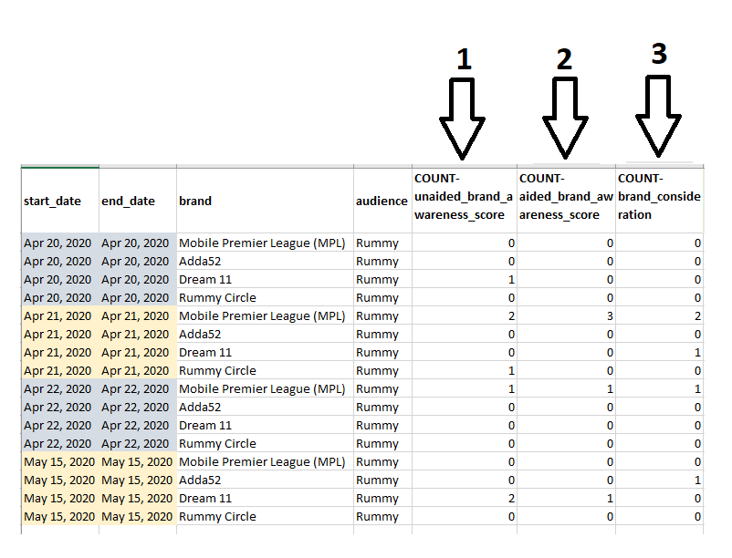

### Step -3

Add one to all the count   
these columns data  
COUNT-unaided_brand_awareness_score  
COUNT-aided_brand_awareness_score  
COUNT-brand_consideration

## Step -4

**Final score** is calculated by that (count / sum of scores on that date )*10 for one particular date  
Same for all

FINAL-unaided_brand_awareness_score  
FINAL-aided_brand_awareness_score  
FINAL-brand_consideration

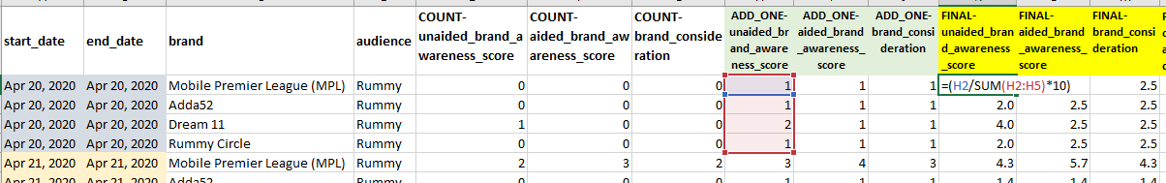  
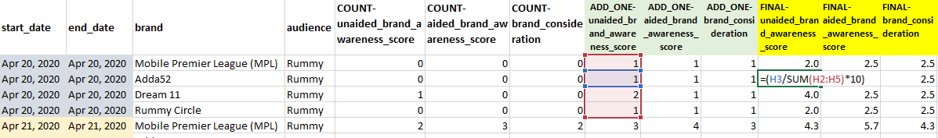

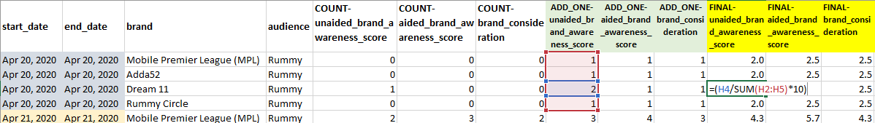

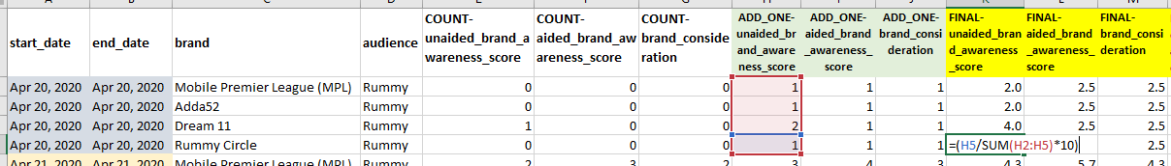

## Step-5

FINAL-overall_brand_consideration  
  
=(**FINAL-unaided_brand_awareness_score**\*5+**FINAL-aided_brand_awareness_score**\*3+**FINAL-brand_consideration**\*2)/10

So finally the scores that are calculated in these columns are the scores- (check with the output file)

|  |  |  |  |
| --- | --- | --- | --- |
| **FINAL-unaided_brand_awareness_score** | **FINAL-aided_brand_awareness_score** | **FINAL-brand_consideration** | **FINAL-overall_brand_consideration** |

Now this sample is shown only for one file **Rummy.xlsx**You will have to execute this calculation for all the three files and get the final scores  
This final scores will be in the format that is shown in **MPL_brand_score.csv**

## Step-6

In output file **brand_score.csv** you can see that there is “overall” in “audience” column   
it is calculated on average of scores, for that particulate date and brand -in all three audiences(**Games,Macro,Rummy)**

# For keyword_score.csv

columns to refer from Input file

|  |
| --- |
| What keeps you engaged with MPL? - Rewards |
| What keeps you engaged with MPL? - Engagement |
| What keeps you engaged with MPL? - Community based gaming |
| What keeps you engaged with MPL? - Tournament |

Step-1  
  
Calculate count of responses received for each **Keyword** according to date  
First take a combination of date (available in **input file**-column name- “**Started Time”)** and available **Keywords** (Rewards, Engagement, Community based gaming, Tournaments)  
This **brand** column “Mobile premier League (MPL)” is common for all  
Take start_date and end_date same  
  
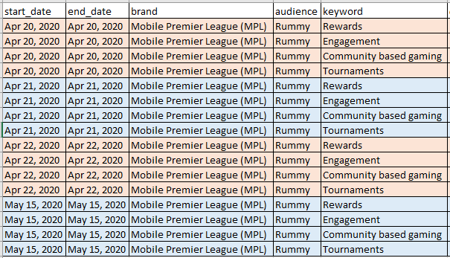

## Step-2

Refer to **Calulation for reference.xlsx (sheet-** **keywordscore)**To get the count for **response count  
Count no. of response for that particular Keyword on that date   
  
Then ADD ONE to all the count**

## Step-3

**Final score** is calculated by that (count / sum of scores on that date )*10 for one particular date  
Same for all

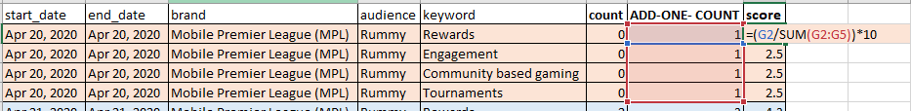

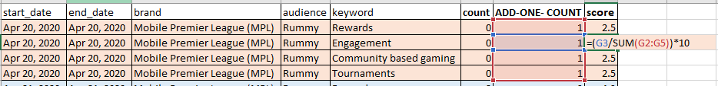

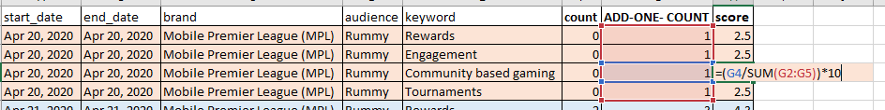

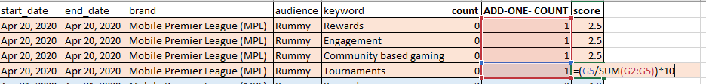

This score is the final score calculated  
Now this sample is shown only for one file **Rummy.xlsx**You will have to execute this calculation for all the three files and get the final scores  
This final scores will be in the format that is shown in **MPL_Keyword_score.csv**

## Step-4

In output file **brand_score.csv** you can see that there is “overall” in “audience” column   
it is calculated on average of scores, for that particulate date and brand -in all three audiences(**Games,Macro,Rummy)**

# End date modification

**Refer brand_score.csv for example**After getting final scores in brand_score.csv and keyword_score.csv  
  
As the start date and end date are same  
we need to update end date  
  
for missing date ranges  
  
  
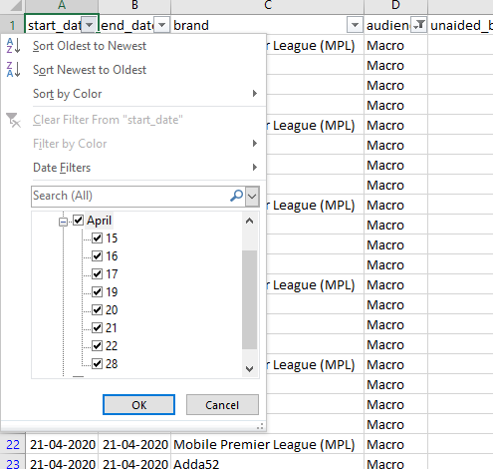  
  
here for particular audience  
date there is continuous 15,16,17,18,19,20,21,22 after this 28  
The missing dates needs to be modified

so now change the end date of   
for that 22 start date , end date will be 27  
so that there is continuous dates  
  
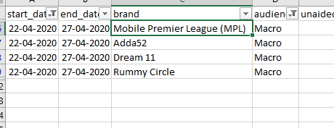  
  
**Note:**

This modification to be done for all missing dates separately for each “**Audience**”

This needs to be done for both **brand_score.csv** and **keyword_score.csv**

Where after all calculation of scores